Thanksgiving is a special holiday celebrated in the United States. Families sit around the table to have dinner and offer prayers to the Lord, for his continuous grace.
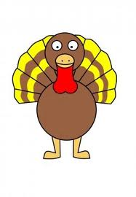

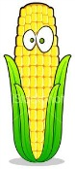
As a large part of traditional food are: turkey, cornbread, stuffing, gravy, mash potato, sweet potato and cranberry sauce.
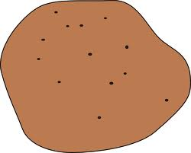
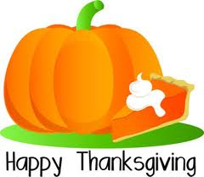

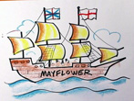
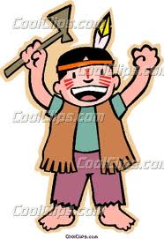
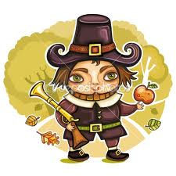
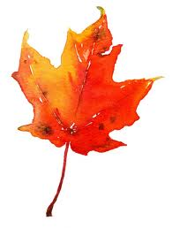
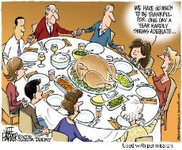
potato corn pumpkin pie turkey hat

indian pilgrim maple leaf dinner Mayflower

